Teacher Assistant Position Profile
OVO HEAD START
Locations: Scottsburg
Salary: $28,122 annually plus excellent benefit package

Teacher Assistant Position Overview
OVO seeks a creative, energetic, compassionate person to assist with early educational instruction and daily activities in the classroom. Our staff to child ratio helps to ensure individualized services and staff support. There are no more than 16 preschoolers assigned to a classroom. There are at least two staff in each classroom consisting of a Teacher and Teacher Assistant. The workday is Monday-Friday from 8:00 am to 4:00 pm. Mondays are reserved for preparation and training with no children present. Children attend classes Tuesday-Friday.

Ohio Valley Opportunities Organizational Overview
OVO is a Community Action Agency incorporated in 1965. Since then, we have led the way in developing innovative programs to meet the needs of low-income individuals and families in Jefferson, Jennings, and Scott counties. We still believe in the mission that we started over 55 years ago: to help reduce the barriers that prevent the low-income population from reaching self-sufficiency.

Our programs are uniquely structured in that they offer specialized programming in our communities. It is a coordinated effort to address the root effects of poverty and to, ultimately, move families and individuals to self-sufficiency. OVO collaborates with nearly 100 community agencies, local elected officials, community-based partners, and stakeholders. Our Community Services Block Grant (CSBG) provides core funding to reduce poverty, revitalize low-income communities, and empower low-income families to become self-sufficient. As a member of a state-wide CSBG network, OVO mobilizes additional resources to combat the central causes of poverty and focus efforts toward increased self-sufficiency, improved living conditions, ownership of and pride in communities, and strong family and support systems. Community representation and accountability are hallmarks of the CSBG network. OVO provides all of its services without regard to race, age, color, religion, sex, disability, national origin, ancestry, or status as a veteran.

Head Start Program Overview
Head Start is a federally funded, comprehensive preschool program to prepare children and families for school success. We teach science, math, literacy skills, art, self-help skills, and much more in our safe, fun classrooms. At Head Start, our goal is to help every child to be physically, emotionally, and cognitively ready for school. Our program offers:
- Quality education
- An evidenced-based curriculum
- Healthy meals and snacks
- Hearing, Vision, Health, Dental Screenings
- Mental Health Services
- Speech and Disability Services
- Parent training
- Referrals

Organizational Strengths

Head Start is one of the many programs operated by OVO.
- We value our staff.
- We are proud of our strong financial position.
- Our reputation is excellent for the quality of services provided.

Initial Focus for the Teacher Assistant
- Assist with daily classroom activities as determined by the Teaching Team.
- Assist with daily classroom and playground schedules, routines and transition activities.
- Work collaboratively with all staff to provide for the needs of children in compliance with Head Start Program Performance Standards.
- Attend all assigned training and meetings.
- Submit timely, neat and accurate documentation.
- Provide ongoing communication and information sharing with staff and parents.
- Assist with home visits and conferences.

Longer term Focus for the Teacher Assistant
- Advocate for early childhood education through ensuring quality services to children, families and community.
- Adhere to all Personnel Policies, Head Start Program Performance Standards and the Policies and Procedures Indiana Childcare Licensing Regulations.
- Assist with completing developmental screenings and regularly assess children's needs.
- Demonstrate knowledge of and approaches to positive guidance and discipline.
- Respond competently to the diverse cultures, traditions, lifestyles, languages, and values of each family.

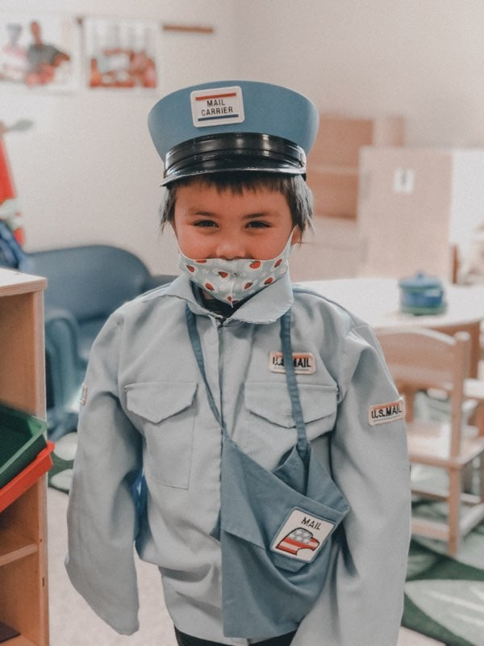
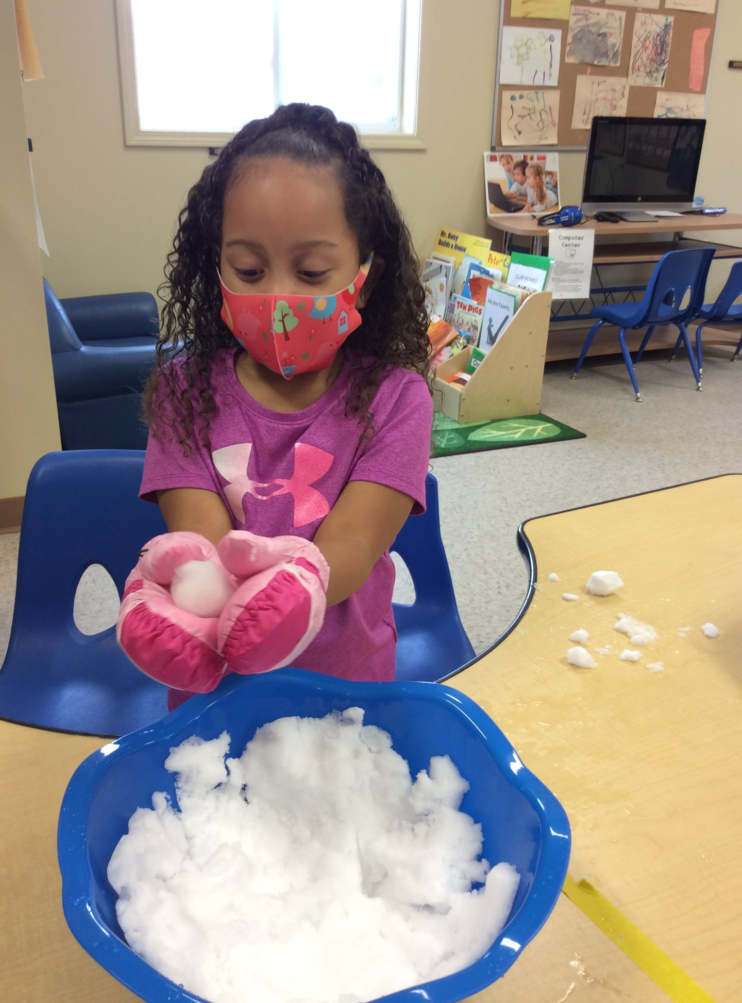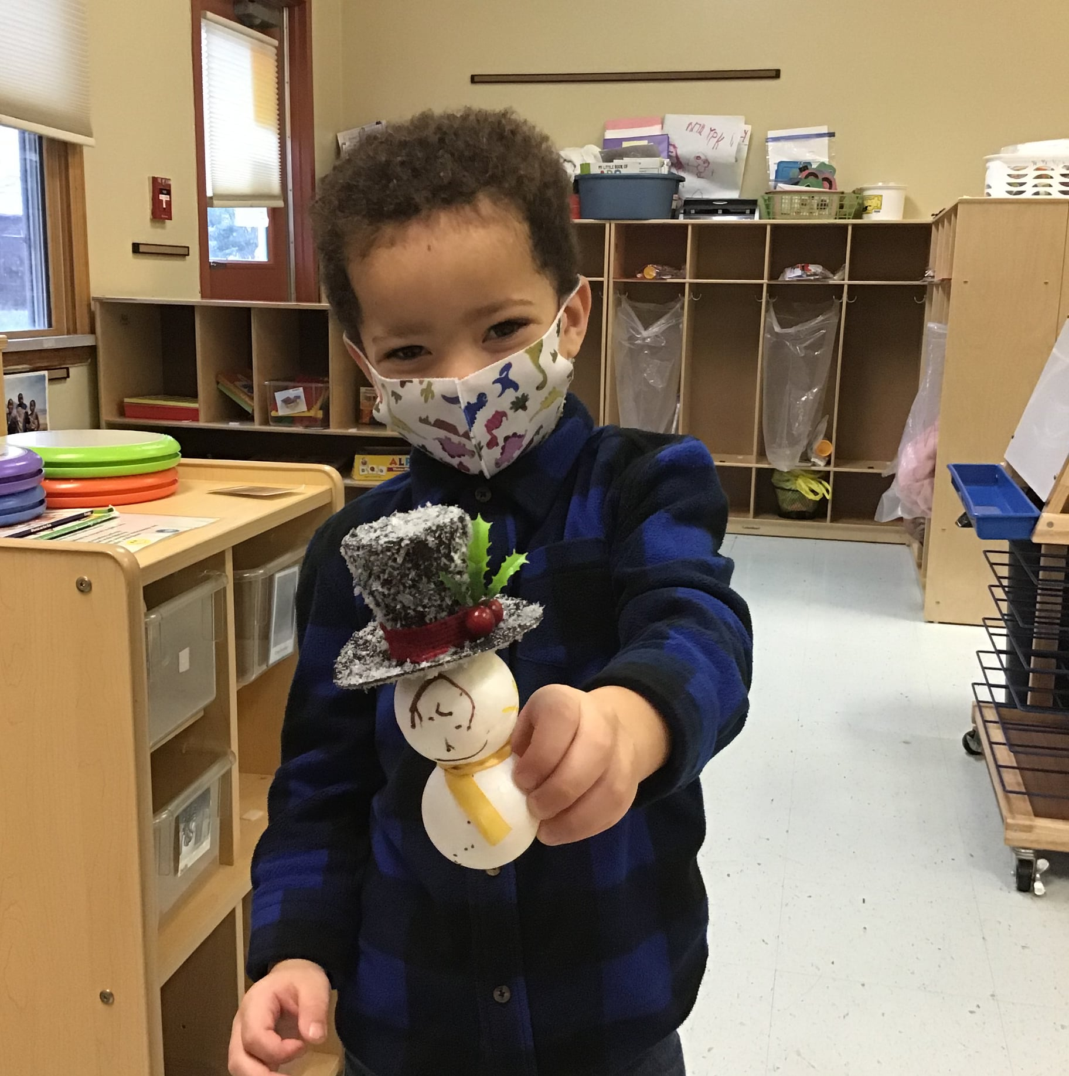

The Position
Reporting to the Center Director, the Teacher Assistant assists in the instructing of children in activities designed to promote social, physical, and intellectual growth to reach School Readiness Goals.

Qualifications
- Associates degree in Early Childhood Education or a related field with relevant course work.
- Prefer one year of experience in a classroom setting; related experience working with children or in an educational or social service setting may be considered in lieu of classroom experience.
- Must be able to be certified in CPR, First Aid and Universal Precautions and maintain certification throughout employment.
- Regularly required to stoop, kneel, crouch, or crawl and talk or hear.
- Frequently required to stand, walk, sit, use hands to finger, handle or feel, and reach with hands and arms.
- Occasionally lift and/or move up to 50 pounds.
- Specific vision abilities required include close vision, distance vision, and peripheral vision.

Personal Attributes Required for Success
- Commitment to Early Childhood Education
- Excellent communicator
- Collaborative
- Comfortable with change
- Relatable, responsive to others
- Well organized
- Critical thinker

SUPERVISORY RESPONSIBILITIES
This job has no supervisory responsibilities

Timing and Application Process
Applications received by 5:00 p.m. on Monday, July 5, 2021 are assured full consideration. It is wise to apply earlier if possible because additional application materials may be requested. It is anticipated that final candidate interviews will be held the week of July 19, 2021 with a decision made shortly thereafter.

To register as a candidate or view more information, please go to:
http://www.ovoinc.org
All submissions will be acknowledged and will be held in strict confidence. All results are held strictly confidential.

Contact Information
For further information, please contact: Jamie Bare at (812) 265-5858. Or email: jbare@ovoinc.org
EQUAL OPPORTUNITY
OVO is committed to creating an equitable organization that is inclusive and representative of the communities we serve. We recognize that our diversity is our strength, and it is critical to advancing our mission and enhancing the well-being of participants, staff, volunteers, and the community.
As an affirmative action/equal opportunity employer, it is our policy to provide equal employment opportunities to all qualified individuals without regard to race, color, religion, national origin, marital or veteran status, genetic information, gender, age, non-disqualifying physical or mental disability, sexual orientation or any other legally protected status.

